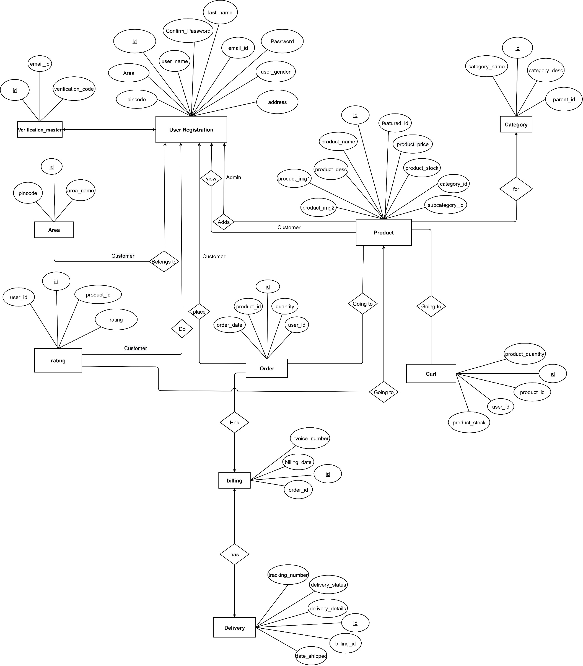

**[Figure 5: ER-Diagram]**